

Foundations of Programming

Assignment No.: 21
PROBLEM STATEMENT: Write a C program to copy contents of one file to another using file handling.

OBJECTIVE:

- To understand the concept of file handling in the C programming language.
- To learn how to read data from a file and write data into another file.
- To implement file copy operation using standard file handling functions.

THEORY:
File handling in the C programming language allows programs to store and retrieve data from files. Files are handled using file pointers and standard functions such as fopen(), fclose(), fgetc(), and fputc().

In this program, the source file is opened in read mode, and the destination file is opened in write mode. The program reads characters from the source file one by one using fgetc() and writes them to the destination file using fputc(). This process continues until the end of the file (EOF) is reached. Thus, the contents of the source file are successfully copied into the destination file.

PLATFORM: Linux

ALGORITHM:
Step 1: Start.
Step 2: Declare two file pointers (fp1 and fp2) and an integer variable (ch).
Step 3: Open the source file (source.txt) in read mode ("r") using fp1.
Step 4: Check if fp1 is NULL.
- If Yes: Print a "File not found" error message and go to Step 14 (Exit).
- If No: Continue to Step 5.
Step 5: Open the destination file (destination.txt) in write mode ("w") using fp2.
Step 6: Check if fp2 is NULL.
- If Yes: Print a "Cannot create file" error message, close fp1, and go to Step 14 (Exit).
- If No: Continue to Step 7.
Step 7: Read a character from fp1 using fgetc() and store it in ch.
Step 8: Check if ch is equal to EOF (End of File).
- If Yes: Go to Step 11.
- If No: Continue to Step 9.
Step 9: Write the character ch into fp2 using fputc().
Step 10: Read the next character from fp1 into ch and loop back to Step 8.
Step 11: Close both files (fp1 and fp2) using fclose().
Step 12: Print a "File copied successfully" message.
Step 13: Return 0.
Step 14: Stop.

FLOWCHART:
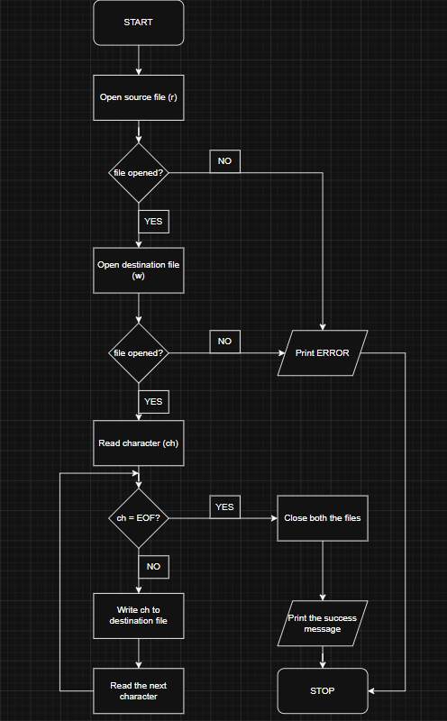

CODE:
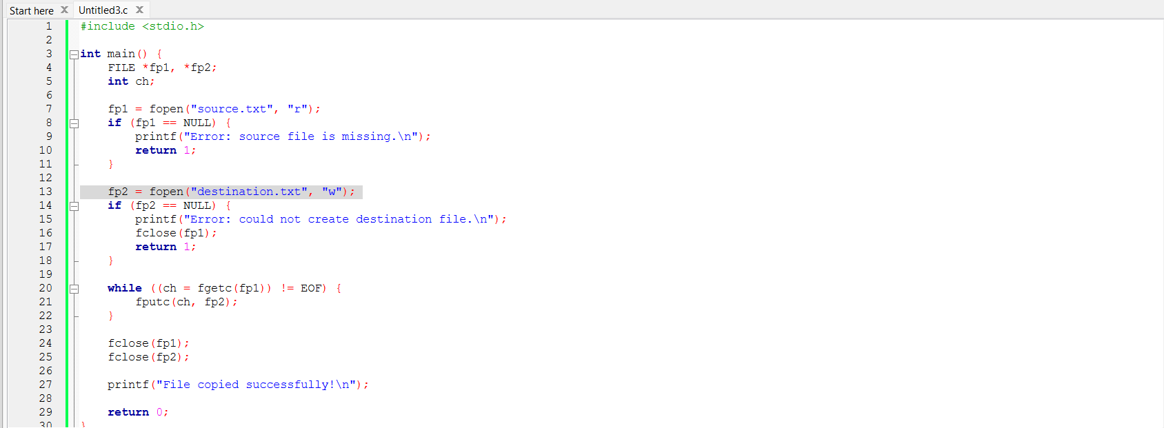

INPUT: THE SOURCE FILE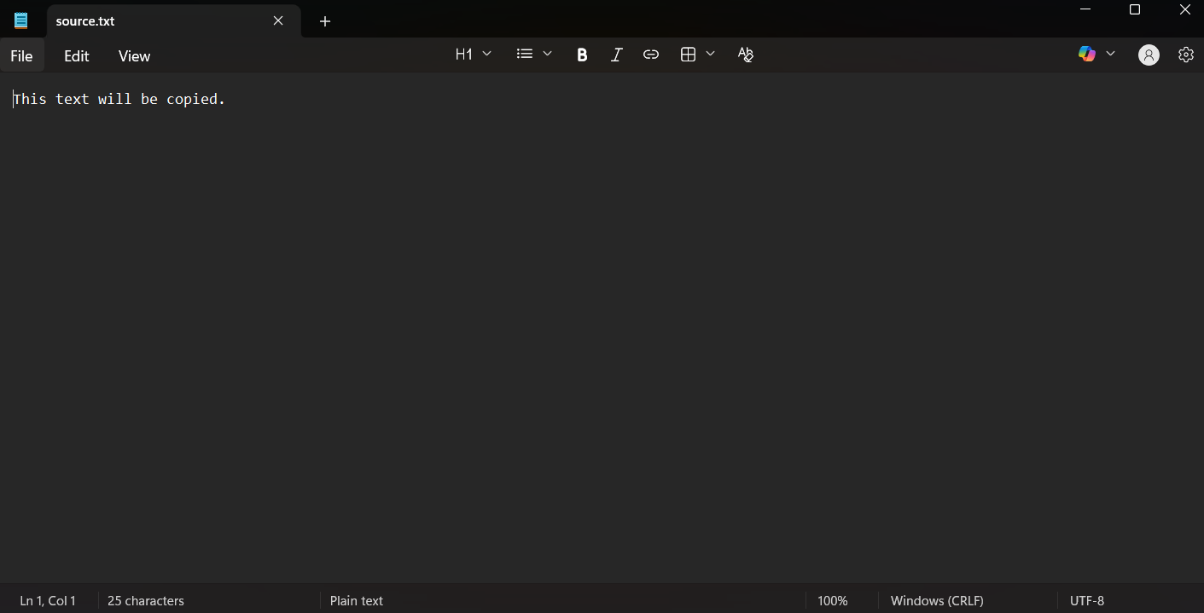

OUTPUT: PREVIOUSLY THE DESTINATION FILE
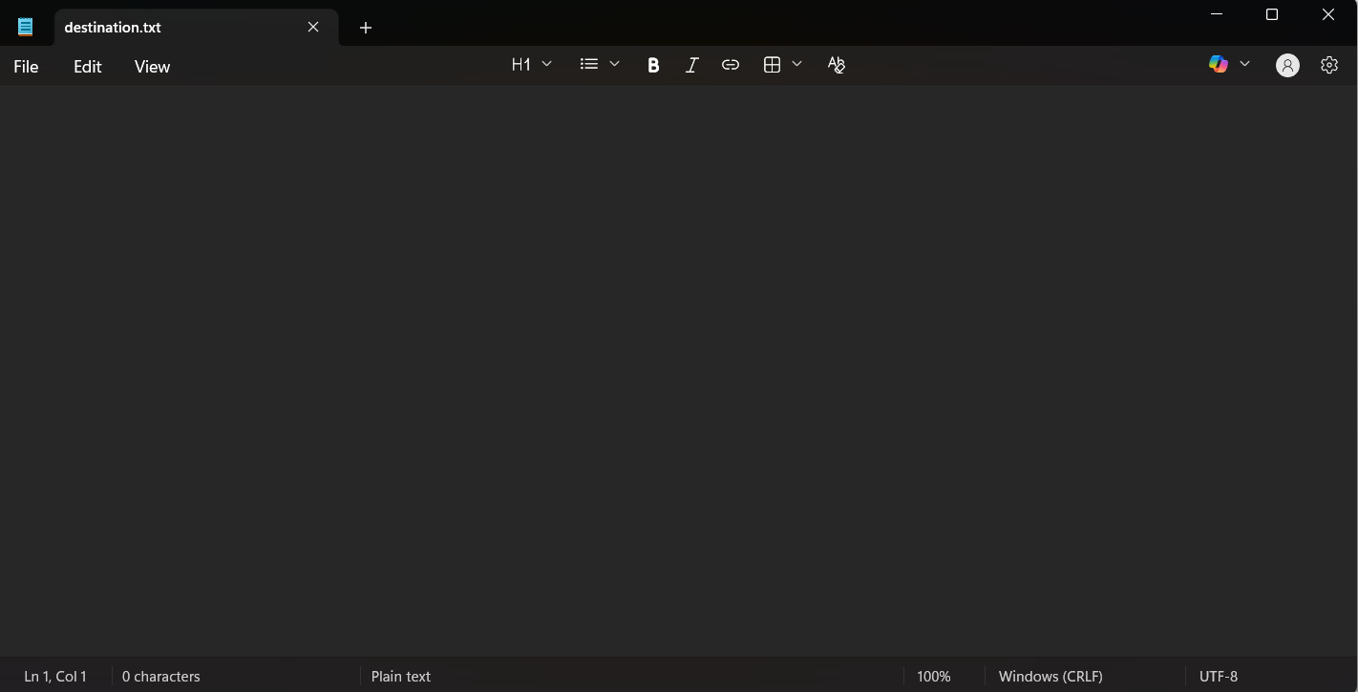

NOW THE DESTINATION FILE
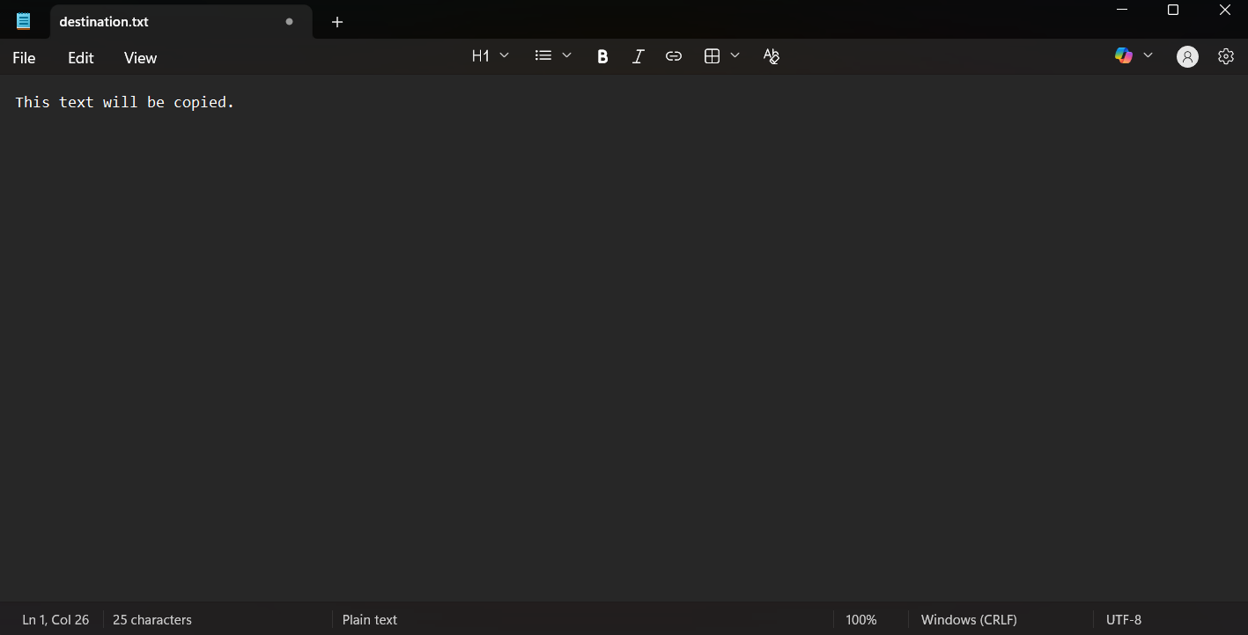

SAMPLE INPUT:
THIS TEXT WILL BE COPIED
SAMPLE OUTPUT:
File copied successfully.

CONCLUSION: Thus, the C program successfully demonstrates file handling operations by copying the contents of one file into another using file handling functions.

FAQs:
- What is file handling in C programming, and why is it important?
- What is the purpose of fopen() and fclose() functions in file operations?
- How does the program detect the end of a file using EOF?

